**1. What are the various elements of the Excel interface? Describe how**

**they're used.**

**ANSWER=**

1. **Ribbon:**
   * **The Ribbon is a tabbed toolbar at the top of the Excel window that contains various tabs, each representing a category of commands.**
   * **Tabs include Home, Insert, Page Layout, Formulas, Data, Review, and View, among others.**
   * **Users can navigate through tabs to access different groups of related commands for formatting, data manipulation, and more.**
2. **Worksheet:**
   * **The main area of the Excel interface is the worksheet, which is a grid of cells organized in rows and columns.**
   * **Users can enter and manipulate data in cells, perform calculations, and create formulas and functions.**
3. **Column Headers:**
   * **Columns are labeled with letters (A, B, C, etc.) at the top of the worksheet.**
   * **Users can click on a column header to select the entire column.**
4. **Row Headers:**
   * **Rows are labeled with numbers (1, 2, 3, etc.) on the left side of the worksheet.**
   * **Users can click on a row header to select the entire row.**
5. **Formula Bar:**
   * **The Formula Bar is located above the worksheet and displays the contents of the active cell.**
   * **Users can enter or edit data, formulas, or functions directly in the Formula Bar.**
6. **Status Bar:**
   * **The Status Bar is located at the bottom of the Excel window and provides information about the current status of the workbook, including sum, average, and other statistics for selected cells.**
   * **It also includes options for changing the view, zoom level, and other settings.**
7. **Sheet Tabs:**
   * **Sheet Tabs are located at the bottom of the Excel window and represent individual sheets within the workbook.**
   * **Users can switch between sheets by clicking on the tabs.**
8. **Quick Access Toolbar:**
   * **The Quick Access Toolbar is a customizable toolbar located above the Ribbon.**
   * **It provides quick access to commonly used commands such as Save, Undo, and Redo.**
9. **File Tab (Backstage View):**
   * **The File tab, also known as the Backstage View, is located in the top-left corner. It provides access to file-related commands such as Save, Open, and Print.**
10. **Zoom Slider:**
    * **The Zoom Slider is in the bottom right corner of the Excel window, allowing users to zoom in or out of the worksheet.**

**QUESTION 2. Write down the various applications of Excel in the industry.**

**ANSWER=**

1. **Finance and Accounting:**
   * **Budgeting and financial forecasting.**
   * **Financial analysis and modeling.**
   * **Creating and managing financial statements.**
   * **Cash flow analysis and management.**
2. **Business Analysis and Reporting:**
   * **Data analysis and visualization.**
   * **Business performance reporting.**
   * **KPI tracking and analysis.**
   * **Dashboard creation for key metrics.**
3. **Project Management:**
   * **Gantt charts for project scheduling.**
   * **Task tracking and management.**
   * **Resource allocation and capacity planning.**
   * **Project budgeting and cost tracking.**
4. **Human Resources:**
   * **Employee data management.**
   * **Payroll processing and tracking.**
   * **Recruitment and applicant tracking.**
   * **Training and development tracking.**
5. **Sales and Marketing:**
   * **Sales tracking and forecasting.**
   * **Customer relationship management (CRM) data analysis.**
   * **Marketing campaign analysis.**
   * **Lead tracking and conversion analysis.**
6. **Inventory Management:**
   * **Tracking and managing inventory levels.**
   * **Order processing and fulfillment tracking.**
   * **Demand forecasting and analysis.**
7. **Data Analysis and Reporting:**
   * **Statistical analysis and data visualization.**
   * **Data cleaning and transformation.**
   * **Pivot tables and charts for summarizing data.**
   * **Customized reporting for decision-making.**

**QUESTION 3. On the ribbon, make a new tab. Add some different groups, insert commands in the groups and name them according to their commands added. Copy and paste the screenshot of the steps you followed.**

**ANSWER=** How to customize ribbon in Excel

.Go to File > Options > Customize Ribbon.

.Right-click on the ribbon and select **Customize the Ribbon…** from the context menu:

**How to create a new tab**

In the Customize the Ribbon window, under the list of tabs, click the New Tab button.

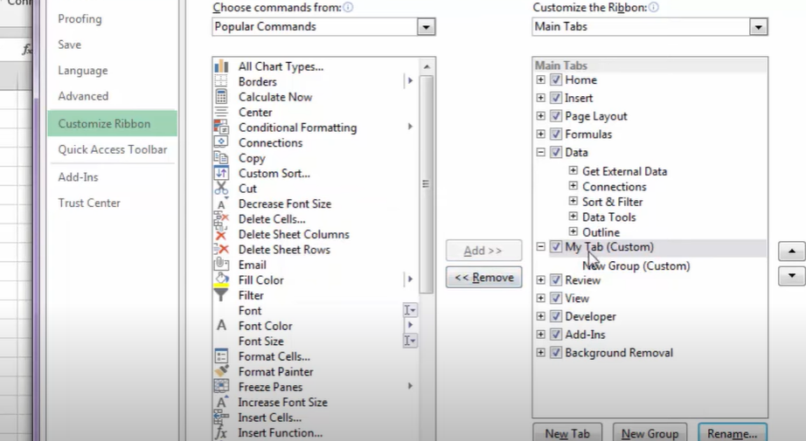

**HOW TO ADD NEW GROUP**

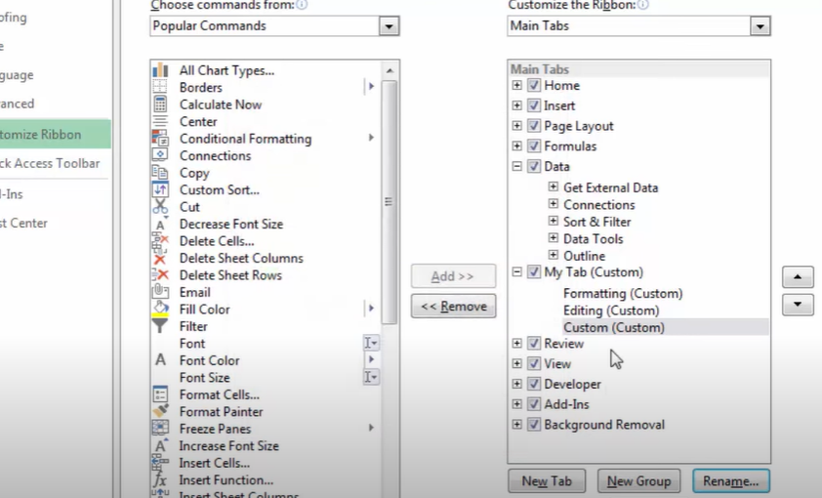

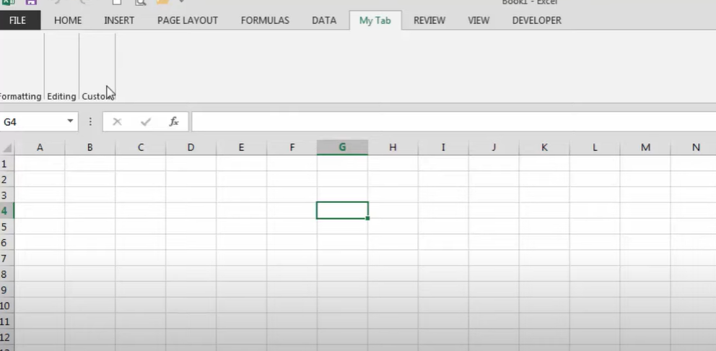

**QUESTION 4. Make a list of different shortcut keys that are only connected to**

**formatting with their functions.**

**ANSWER=**

Ctrl + B: Bold

Ctrl + I: Italic

Ctrl + U: Underline

Ctrl + E: Center alignment

Ctrl + L: Left alignment

Ctrl + R: Right alignment

Ctrl + J: Justify alignment

Ctrl + 1: Single line spacing

Ctrl + 2: Double line spacing

Ctrl + 5: 1.5 line spacing

Ctrl + Shift + >: Increase font size

Ctrl + Shift + <: Decrease font size

Ctrl + Shift + +: Superscript

Ctrl + =: Subscript

Ctrl + Shift + L: Bulleted list

Ctrl + Shift + L: Numbered list

Ctrl + Shift + C: Copy formatting

Ctrl + Shift + V: Paste formatting

Ctrl + 0: Add or remove 10 points of spacing before a paragraph

Ctrl + T: Create a hanging inden

**QUESTION 5. What distinguishes Excel from other analytical tools?**

**ANSWER=**

1. **User-Friendly Interface:** Excel has a user-friendly interface that allows both beginners and experienced users to work with data easily. The grid-like structure of cells makes it intuitive for organizing and manipulating data.
2. **Versatility:** Excel is a versatile tool that goes beyond just data analysis. It can be used for data entry, calculations, charting, and even simple database management. This versatility makes it a go-to tool for a wide range of tasks.
3. **Formulas and Functions:** Excel is known for its powerful formulas and functions. Users can perform complex calculations, statistical analysis, financial modeling, and more using built-in functions like SUM, AVERAGE, VLOOKUP, and others.
4. **Data Visualization:** Excel provides robust charting and graphing capabilities. Users can create a variety of charts and graphs to visualize data trends, patterns, and relationships. This makes it a valuable tool for presenting data to others**.**
5. **Integration with Other Microsoft Office Applications:** Excel seamlessly integrates with other Microsoft Office applications like Word and PowerPoint. This integration allows users to transfer data and charts between applications, enhancing overall productivity**.**
6. **PivotTables and PivotCharts:** Excel's PivotTable and PivotChart features enable users to analyze and summarize large datasets quickly. These tools are particularly powerful for data summarization and analysis.
7. **Macro and VBA Support**: Excel supports macros and Visual Basic for Applications (VBA), allowing users to automate repetitive tasks and create custom functions. This capability enhances productivity and extends Excel's functionality**.**
8. **Data Validation and Protection**: Excel provides features for data validation, allowing users to control the type and format of data entered into cells. Additionally, it offers password protection and other security features to safeguard sensitive information**.**

**QUESTION 6. Create a table and add a custom header and footer to your table.**

**ANSWER=**

**HEADER**

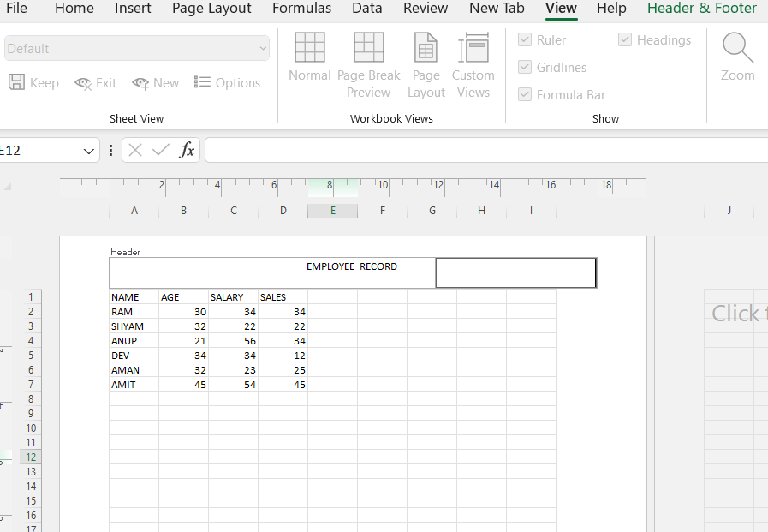

**FOOTER**

